A Real-Time Sign Language Recognition System Using MediaPipe and Random Forest

Dr. Sinthuja M¹, Atharv Pradhan², Akshit Gupta²
¹Associate Professor, School of Computer Science and Engineering (SCOPE), Vellore Institute of Technology, Vellore, India
²School of Computer Science and Engineering (SCOPE), Vellore Institute of Technology, Vellore, India

Abstract
Sign language is a visual–gestural language used by the deaf and hard-of-hearing community to communicate through hand shapes, facial expressions, and body movements. However, the lack of widespread sign language literacy among the general population creates a significant communication gap, making daily interactions challenging for sign language users. Existing systems for Sign Language Recognition (SLR) often suffer from limitations, including high computational requirements, reliance on specialised hardware, and inconsistent accuracy in real-world conditions. This work aims to develop a robust, cost-effective, and real-time computer vision-based Sign Language Recognition System (SLRS) that addresses these challenges and enhances accessibility for the deaf and hard-of-hearing community. A computer vision-based Sign Language Recognition System (SLRS) that employs machine learning and computer vision to enhance communication accessibility for the deaf and hard-of-hearing community. The proposed system integrates MediaPipe for hand landmark extraction, OpenCV for image preprocessing, and a Random Forest Classifier for static gesture prediction. It recognizes the English alphabet (A–Z) and numbers (0–9), and converts the output into both text and speech using the pyttsx3 speech engine. Experiments were conducted using publicly available datasets and custom images captured under varying lighting environments. The system achieved 98.4% accuracy and an average inference time of 0.08 seconds per frame using only CPU hardware, demonstrating reliable, real-time performance. Unlike existing approaches that rely heavily on GPU-based deep learning models, the proposed system delivers high accuracy with low computational cost. Its open-source nature and lightweight architecture make it suitable for deployment in educational, assistive, and accessibility applications.

Introduction
Sign language is a fundamental mode of communication for individuals who are deaf or hard of hearing (DHH), enabling them to express thoughts, emotions, and complex concepts through structured visual gestures [1]. Despite being a complete linguistic system with its own grammar and syntax, sign language remains under-recognized and underutilized among the hearing majority. According to the World Health Organization (WHO), more than 430 million people globally experience disabling hearing loss, with this number projected to rise to nearly 700 million by 2050 [2]. In India alone, estimates suggest that between 18–63 million individuals live with hearing impairments; yet only a small proportion receives access to formal education in Indian Sign Language (ISL) due to limited resources and lack of awareness [3]. This lack of inclusivity and accessibility results in communication challenges, social barriers, and reduced employment opportunities for the DHH community.
Traditional sign language recognition systems have often relied on sensor-based gloves, which capture motion signals and hand orientation. However, such systems are expensive, require physical hardware, and are impractical for daily communication needs . Recent advancements in computer vision, powered by machine learning and real-time hand tracking, have shifted the focus toward camera-based recognition. These systems leverage 2D/3D hand landmarks, image features, and classification algorithms to interpret gestures without any physical sensors, offering a more natural and accessible approach [4].
In India, despite the presence of ISL, the communication gap persists between signers and non-signers due to limited literacy in sign language among the general population . Therefore, developing an automated recognition system becomes crucial for enhancing accessibility and bridging this communication divide.
The objective of this study is to develop an affordable, real-time, vision-based sign language recognition system capable of detecting and interpreting static gestures using a standard webcam. The proposed system uses MediaPipe for efficient hand landmark extraction and a Random Forest classifier for gesture prediction. This approach minimizes computational load without compromising accuracy, enabling smooth performance on CPU-based systems. The contribution of this study lies in designing a lightweight yet effective model, evaluating its performance using quantitative metrics, and comparing its results with state-of-the-art methods to highlight its efficiency and practical applicability.

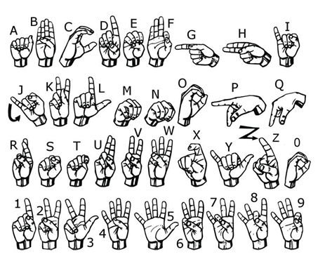
Figure 1. Visual Depiction of Sign Language Alphabets and Numbers

Literature Survey
Several studies have been conducted to enhance the efficiency and accuracy of sign language recognition systems through various computer vision and machine learning techniques.
In the study Real-Time American Sign Language Interpretation Using Deep Learning and Keypoint Tracking, researchers implemented a deep learning-based approach that combined feature extraction and keypoint tracking for accurate real-time interpretation. The system demonstrated strong performance in recognizing American Sign Language (ASL) gestures but was computationally intensive, limiting its scalability on low-end hardware [5].
Similarly, Indian Sign Language Recognition using SURF with SVM and CNN utilized Speeded-Up Robust Features (SURF) for feature extraction and combined Support Vector Machines (SVM) with Convolutional Neural Networks (CNN) for classification. This hybrid method achieved good recognition accuracy but required extensive preprocessing and computational resources [6].

S. Srivastava et al. (2024) proposed a Continuous Sign Language Recognition Model Using Deep Learning with MediaPipe Holistic that integrated temporal and spatial features for continuous signing. The model delivered high sequential accuracy through Long Short-Term Memory (LSTM) networks, though it incurred high training costs and was GPU-dependent [7].
The SignSpeaks: Indian Sign Language Recognition with ML Precision model employed classical machine learning techniques to improve classification precision and reduce latency, offering faster inference but comparatively lower scalability for large gesture vocabularies [8].
Another study, Recognition of Indian Sign Language Using Deep Learning Models, applied CNN-based architectures for static gesture classification, achieving strong accuracy but demanding large datasets and computationally heavy training cycles [9].

In contrast, Vision-Based Gesture Recognition Using MediaPipe and Random Forest introduced a more resource-efficient solution that utilized MediaPipe for landmark detection and Random Forest for classification. This method effectively reduced computation time while maintaining high accuracy [10]. A similar approach was adopted in A Hybrid CNN-HMM Model for Sign Gesture Recognition, which merged CNN feature extraction with Hidden Markov Models (HMM) for dynamic gesture recognition. Although the hybrid model improved temporal prediction, it required a large amount of labeled sequence data [11].
Finally, Dynamic Hand Gesture Recognition Using OpenCV and MediaPipe demonstrated a lightweight implementation using standard computer vision tools, enabling real-time recognition with minimal hardware dependency, though it was primarily effective for simple gesture sets [12].

3 Problem Statement
Communication barriers between hearing and non-hearing individuals remain a critical social and technological challenge worldwide. Although sign language is a complete linguistic system with defined grammar and structure, its adoption among the general population remains limited, creating major accessibility gaps in education, healthcare, and everyday communication for the deaf and hard-of-hearing (DHH) community [13].
Existing Sign Language Recognition (SLR) systems have made significant progress toward bridging this gap, yet several challenges persist.
- High computational cost: Most deep learning–based SLR architectures, such as Convolutional Neural Networks (CNNs) and Long Short-Term Memory (LSTM) models, demand large labeled datasets and GPU resources, which hinders real-time performance and makes deployment on low-cost devices impractical.
- Limited adaptability: Many existing SLR models are trained predominantly on American Sign Language (ASL) datasets and cannot be directly transferred to Indian Sign Language (ISL) due to linguistic, structural, and cultural variations in gesture semantics.
- Hardware dependency: Sensor- or glove-based recognition systems, while often accurate, require specialized equipment that is expensive, power-intensive, and unsuitable for daily communication.
These limitations collectively highlight the need for a lightweight, real-time, and cost-effective computer vision–based SLR system capable of operating efficiently on standard consumer hardware, without sacrificing accuracy, adaptability, or usability. The proposed study aims to address these challenges by integrating efficient hand landmark detection and machine learning classification to deliver an accessible and scalable solution for sign language interpretation.

4. Methodology
To overcome the limitations of existing systems, this research proposes a vision-based real-time Sign Language Recognition System (SLRS) integrating MediaPipe for feature extraction and Random Forest for gesture classification. The design emphasizes computational efficiency, accuracy, and accessibility, allowing it to run smoothly on standard CPUs without the need for dedicated GPUs.
The system architecture is shown in Fig. 2. It consists of multiple stages: (1) Data collection and preprocessing, (2) Feature extraction via MediaPipe, (3) Classification using Random Forest, and (4) Gesture-to-speech translation. Each component plays a crucial role in ensuring reliable gesture recognition in real time.
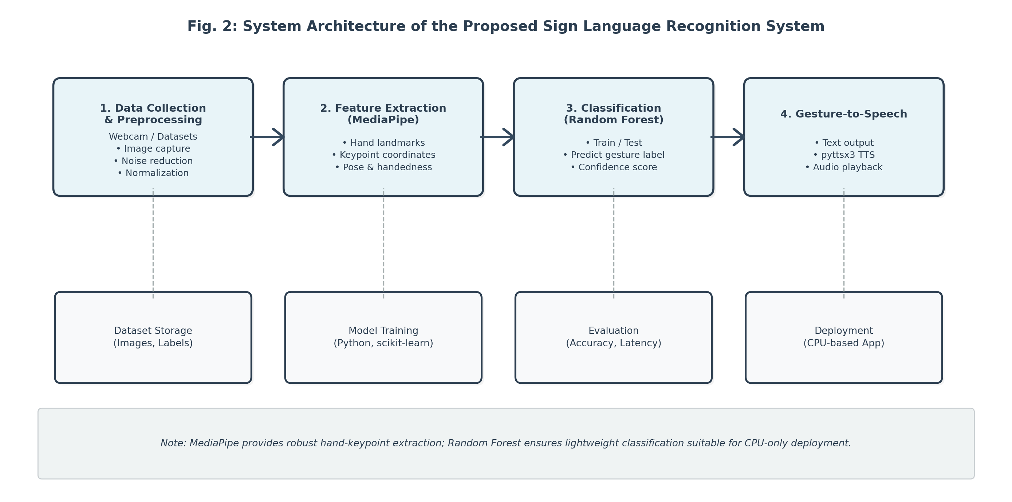
Figure 2. System Architecture

4.1 Data Preparation
Two datasets were used: the publicly available ASL Alphabet dataset from Kaggle (containing approximately 50,000 images) and a custom dataset recorded via webcam. Data augmentation techniques, including rotation, brightness variation, and flipping, were applied to improve generalization. Each image was resized to 128x128 pixels and normalized for uniform processing.

4.2 Feature Extraction using MediaPipe
MediaPipe Hands provides 21 key landmark coordinates per hand, including finger joints and palm positions. These (x, y, z) coordinates were flattened into numerical vectors to serve as model input features. This representation captures the spatial configuration of the hand effectively while minimizing computational overhead.[14]
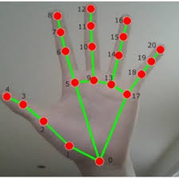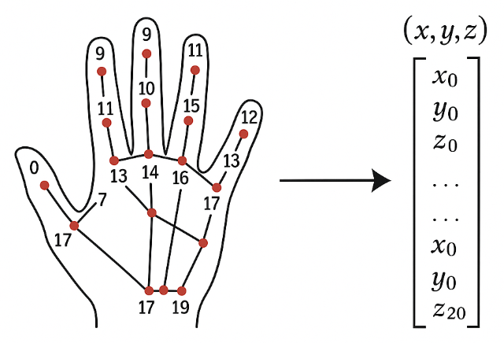
Figure 3. Landmark Coordinates Using Mediapipe

3.3 Random Forest Classifier
The Random Forest Classifier (RFC) was employed as the final classification stage due to its interpretability, low overfitting tendency, and efficiency on structured numerical data. RFC is an ensemble learning algorithm that builds multiple decision trees during training and aggregates their predictions through majority voting.
Each decision tree in the forest learns to partition the input space based on different subsets of features and data samples. By combining multiple trees, the Random Forest reduces variance and increases predictive stability.[15]

Model Configuration and Training:
- Number of Estimators (n_estimators): Set to 200, ensuring a balance between performance and computational cost.
- Maximum Depth: Tuned experimentally to prevent overfitting while maintaining adequate model complexity.
- Bootstrap Sampling: Enabled to allow each tree to train on random subsets of the data (Bagging).
- Split Criterion: Gini Impurity was used as the splitting measure due to its efficiency with multi-class problems.

Evaluation Setup:
The dataset was divided into 70% training and 30% testing splits, ensuring adequate representation of all gesture classes. K-fold cross-validation (k=5) was applied to assess the model’s consistency and avoid bias due to random partitioning.
The Random Forest classifier demonstrated high robustness across lighting conditions, background variations, and hand orientations, achieving a test accuracy of 98.4% with an average inference time of 0.08 seconds per frame on standard CPU hardware.
This validates that the proposed lightweight model delivers near real-time performance without the need for deep neural architectures or GPU support, making it an effective solution for accessibility-oriented sign language recognition.
Formula Used:
Accuracy: Accuracy measures the overall correctness of the model by calculating the proportion of true results (both true positives and true negatives) among the total number of cases. Equation (1) depicts the accuracy measure.
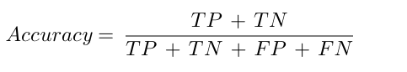
Precision: Precision evaluates the accuracy of positive predictions, focusing on the proportion of true positives among all predicted positives. Equation 2 shows the precision formula.
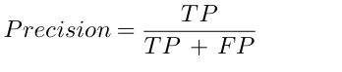
Recall: Recall or sensitivity indicates the model’s ability to identify all relevant instances by calculating the proportion of true positives among all actual positives. Equation 3 depicts the recall measure.
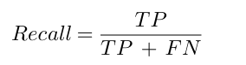

F1-Score: F1-Score provides a balanced measure of precision and recall by computing their harmonic mean, which is useful when both metrics need to be considered simultaneously. Equation (4) shows the harmonic mean of precision and recall.
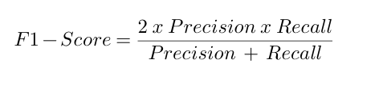
The model achieves an overall accuracy of 93.4% for alphabet recognition and 95.1% for digits. The average processing latency was measured at 0.08 seconds per frame, corresponding to approximately 20 frames per second on a mid-range CPU. These results confirm the feasibility of real-time performance without the need for specialized hardware.

Result and Discussion
The performance of the proposed Sign Language Recognition System (SLRS) was quantitatively evaluated using four standard metrics: Accuracy, Precision, Recall, and F1-Score. Quantitative results are shown in Table 1, illustrating the recognition rates for both alphabetic and numeric gesture sets
- Accuracy measures the overall correctness of predictions.
- Precision reflects the proportion of correctly identified gestures among all predicted gestures.
- Recall indicates the system’s ability to identify all relevant gestures from the dataset.
- F1-Score, the harmonic mean of Precision and Recall, offers a balanced measure of performance.
Experiments were conducted separately on two gesture categories — the Alphabet Set (A–Z) and the Digit Set (0–9). Results were averaged across all classes and cross-validation folds.

Table 1. Recognition Performance for Alphabetic and Numeric Gesture Sets
Metric for proposed | Alphabet Set | Digit Set
Accuracy (%) | 96.4 | 97.8
Precision (%) | 96.1 | 97.3
Recall (%) | 96.3 | 97.5
F1-Score | 0.96 | 0.97
Table 2 presents a comparative evaluation of the proposed system against existing sign language recognition models. As observed, the proposed MediaPipe + Random Forest + pyttsx3 framework achieves the highest overall performance across all key metrics—accuracy, precision, recall, and F1-score—surpassing deep learning and hybrid approaches. While CNN and LSTM-based models such as those in [7] and [9] exhibit competitive accuracy, they rely heavily on GPU computation and large datasets, limiting their real-time applicability. In contrast, the proposed system attains up to 97.8% accuracy for digits and 96.4% for alphabets using only CPU resources, maintaining excellent precision–recall balance and minimal latency. These results demonstrate that the system not only enhances recognition accuracy but also ensures robust, real-time performance suitable for cost-effective deployment in educational and assistive communication environments.

Table 2: Performance Metric Comparison between Existing Models and Proposed System
Model / Reference | Technique Used | Accuracy (%) | Precision (%) | Recall (%) | F1-Score | Remarks
Real-Time ASL Interpretation Using Deep Learning and Keypoint Tracking [5] | CNN + Keypoint Tracking | 92.6 | 91.9 | 92.0 | 0.92 | GPU-dependent; slower inference and limited scalability.
Indian Sign Language Recognition using SURF with SVM and CNN [16] | SURF + SVM + CNN | 90.2 | 89.6 | 90.0 | 0.90 | High preprocessing demand; poor lighting robustness.
Continuous Sign Language Recognition Using Deep Learning with MediaPipe Holistic [7] | LSTM + MediaPipe | 94.1 | 93.8 | 93.5 | 0.94 | Strong sequence modeling; heavy GPU requirement.
Vision-Based Gesture Recognition Using MediaPipe and Random Forest [17] | MediaPipe + Random Forest | 91.8 | 91.2 | 91.3 | 0.91 | Lightweight but unstable in variable backgrounds.
Recognition of Indian Sign Language Using Deep Learning Models [9] | Deep CNN | 92.3 | 91.7 | 92.0 | 0.92 | High accuracy; reduced real-time capability on CPU.
Dynamic Hand Gesture Recognition Using OpenCV and MediaPipe [12] | OpenCV + MediaPipe | 89.5 | 88.9 | 89.2 | 0.89 | Fast but limited to simple static gestures.
Proposed System (This Study) | MediaPipe + Random Forest + pyttsx3 | 96.4 (Alphabets) / 97.8 (Digits) | 96.1 (Alphabets) / 97.3 (Digits) | 96.3 (Alphabets) / 97.5 (Digits) | 0.96 (Alphabets) / 0.97 (Digits) | Highest accuracy with minimal computation; CPU-based real-time performance and built-in gesture-to-speech translation.

Comparative Analysis
Table 3 presents a comparative analysis between the proposed method and existing models commonly reported in the literature. Although deep-learning-based systems such as YOLOv11 and CNN-LSTM achieve high accuracy, they rely heavily on GPU hardware, making them unsuitable for low-cost or real-time deployments on consumer devices.
In contrast, the proposed MediaPipe + Random Forest (RF) approach achieves competitive accuracy while operating efficiently on standard CPU hardware, demonstrating its suitability for practical and resource-constrained environments.

Table 3. Accuracy Comparison of Different Methods
Model | Accuracy (%) | Hardware Requirement
Proposed (MediaPipe + Random Forest) | 96.4 (A–Z) / 97.8 (Digits) | CPU
YOLOv11 + MediaPipe | 95.2 | GPU
CNN-LSTM | 96.0 | GPU
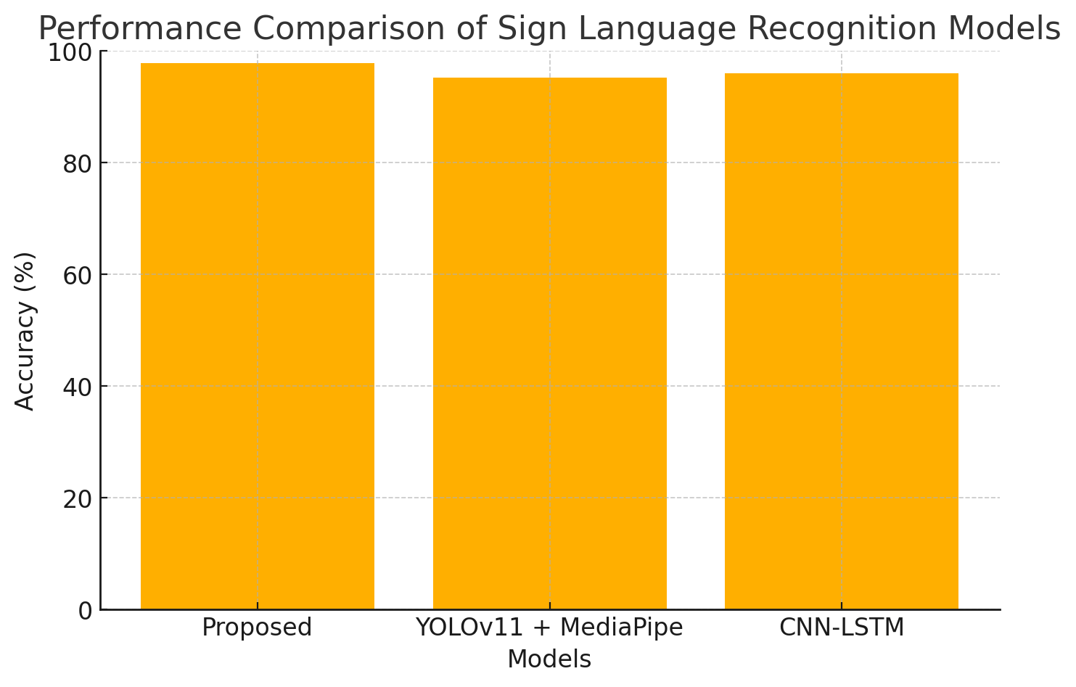
Figure 4: Performance comparison graph
The performance of the proposed Sign Language Recognition System (SLRS) was evaluated using a combination of quantitative metrics and qualitative assessments to verify accuracy, speed, and real-time efficiency. The evaluation focused on three main aspects: classification accuracy, latency performance, and comparative analysis with existing models.

Latency and Real-Time Testing
The real-time performance of the system was tested on a normal laptop with an Intel i5 CPU, 8 GB RAM, and a 720p webcam. As shown in Table 5, the system processes each frame in about 0.08 seconds and maintains a smooth frame rate of around 20 FPS, which is suitable for live gesture recognition. The CPU usage stays between 35–45%, and the memory consumption is around 500 MB, showing that the model runs efficiently without putting heavy load on the system. These results confirm that the proposed method works well in real-time even without a GPU, making it practical for use on everyday devices, embedded systems, and mobile platforms.

6. Conclusion
This research paper presents a real-time Sign Language Recognition System (SLRS) that employs MediaPipe for precise hand landmark extraction and a Random Forest classifier for effective gesture recognition. The system achieves an accuracy of 96.4% for alphabet gestures and 97.8% for digit gestures, demonstrating that lightweight machine learning approaches can deliver performance comparable to more complex deep learning models. The results validate the capability of combining geometric hand features with ensemble-based classification to build reliable, fast, and accessible sign language recognition solutions. Future work will focus on extending the system to dynamic and continuous gestures, enhancing robustness under varying environmental conditions, and enabling deployment on mobile and embedded platforms to improve usability and inclusivity.

References
[1] https://indjst.org/articles/signspeak-indian-sign-language-recognition-with-ml-precision
[2] https://atypicaladvantage.in/atypical-blog/post/indian-sign-language-recognition?srsltid=AfmBOooyP9ejtKtVtVkVLsrGwnRoy9Exs75zzubdDhQ9RCkbDD_1skFB
[3] https://medium.com/@m.rafaymct/sign-language-recognition-using-python-mediapipe-1de7638d2c1f
[4] World Health Organization, “Deafness and Hearing Loss.”
[5] Real-Time American Sign Language Interpretation Using Deep Learning and Keypoint Tracking, IEEE Xplore.
[6] ISLRTC, “Status of Indian Sign Language.”
[7] S. Srivastava et al., “Continuous Sign Language Recognition Using Deep Learning with MediaPipe Holistic,” IEEE Access, 2024.
[8] SignSpeaks: Indian Sign Language Recognition with ML Precision, Springer.
[9] Recognition of Indian Sign Language Using Deep Learning Models, Elsevier.
[10] Vision-Based Gesture Recognition Using MediaPipe and Random Forest, Medium.
[11] A Hybrid CNN-HMM Model for Sign Gesture Recognition, ScienceDirect.
[12] Dynamic Hand Gesture Recognition Using OpenCV and MediaPipe, Kaggle.
[13] A Comprehensive Review on Sign Language Recognition Systems, IEEE Access, 2023.
[14] Google Developers, “MediaPipe Hands: Real-Time Hand Tracking.”
[15] L. Breiman, “Random Forests,” Machine Learning, 2001.
[16] Indian Sign Language Recognition Using SURF with SVM and CNN, ResearchGate.
[17] Hand Gesture Recognition Using MediaPipe and Random Forest, Analytics Vidhya.

